LPO 7870 Research Design and Data Analysis II, 2024
Assignment 4

Submission Guidelines:
- Please submit an electronic copy of your group’s solutions as a PDF file by 4:00 pm, Monday, April 8.
- All submissions via Brightspace in the “Assignments” section —only one submission per group.
- Please include the Stata output (you can copy and paste the main Stata outcomes).
- Pro-tip: if you use Courier New font, Stata output will line up as it does in the output window.

Question 1. Linear Probability Model. (24 points)

The Stata dataset nhes_2019_extract.dta (posted on Brightspace and Github) was derived from the 2019 administration of the National Household Education Survey (NHES) conducted by the National Center for Education Statistics. The variables in this dataset pertain to a focal child in the household as well as the child’s parents or caregivers. For example, there are questions about the type of school the child attends (public, private, charter, homeschool), their grade level, their disability status, etc. (The variables in this extract are only a small subset of all the variables available).

- The variable homeschool equals 1 if the student is homeschooled and 0 otherwise. What proportion of students in this sample were homeschooled? (2 points)

3.23% of students were homeschooled. (In Stata, use summarize homeschool).

- In Stata, estimate a linear probability model where homeschool is the dependent variable and age (age2018) is the sole explanatory variable. Show your resulting output. (5 points)

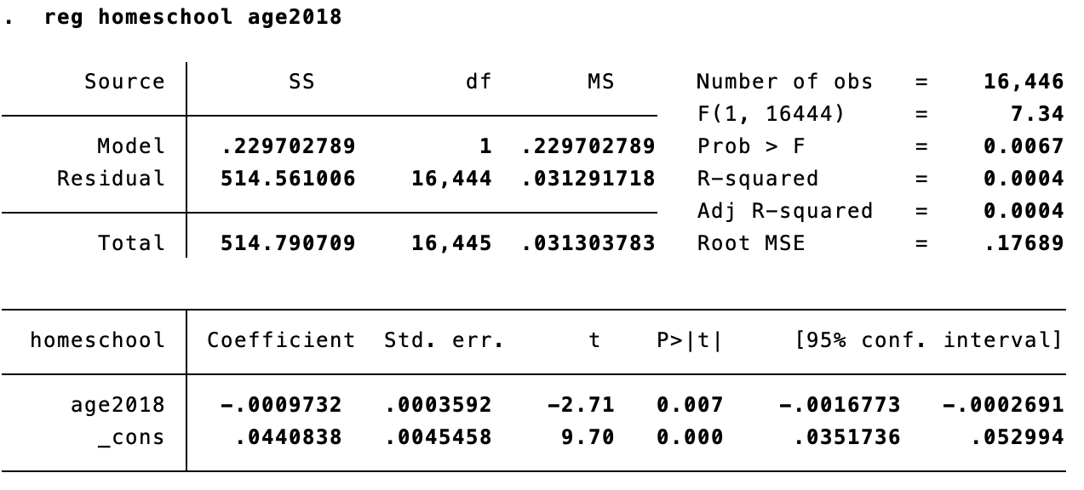

  - Carefully interpret the slope coefficient on age.
A one year increase in a child’s age in 2018 is associated with a 0.097 (-0.00097 *100) percentage point decrease in their likelihood of being homeschooled.
  - Is this coefficient estimate statistically significant? Explain how you know.
Yes, this estimate is statistically significant as it has a p-value of 0.007 which is less than 0.05 and 0.01, the thresholds for statistical significance at the 95% and 99% confidence levels respectively.

- Consider two students, one aged 6 (1st grade) and the other aged 12 (7th grade). Based on your results in part (b), how much more or less likely is the older student to be homeschooled? (4 points)

12-6=6 -> These students have a 6 year age difference
6*(-0.00097) = 0.00582

The 7th grader is 0.58 percentage points less likely to be homeschooled than the 1st grader.

- Now add additional explanatory variables to the linear probability model in (b): child’s race or ethnicity (raceeth), student has a disability (swd), parent’s highest level of education (pargradex), number of siblings (numsibsx), and household internet access (intacc2). Note that raceeth and pargradex are categorical variables; we recommend using the “i.” prefix with these variables so that Stata treats them as such. (5 points)

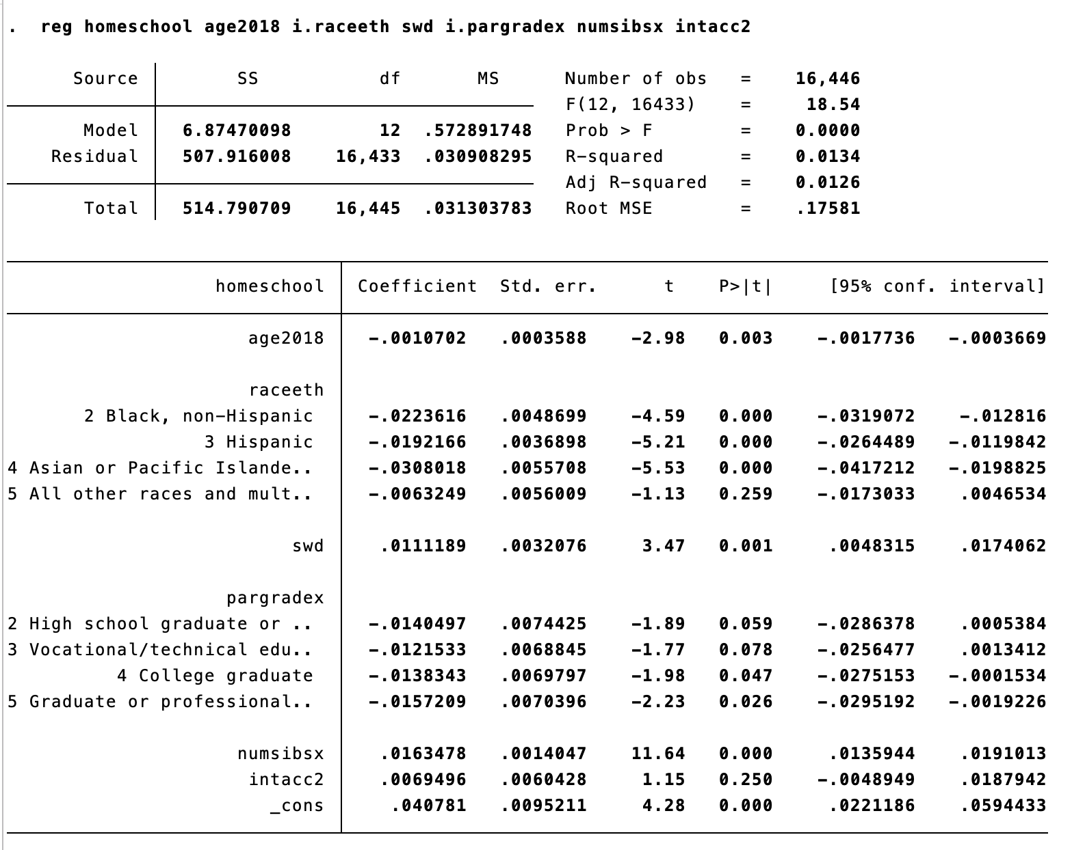

  - Show your resulting output, and comment on how each of these variables is related to students’ likelihood of being homeschooled.

White students are more likely to be homeschooled than Black, Hispanic, or Asian/Pacific Islander Students, holding other characteristics in the model constant. Asian/Pacific Islander Students are the least likely to be homeschooled, holding other characteristics in the model constant.

Students with a disability are 1 percentage point more likely to be homeschooled than students without a disability, holding other characteristics in the model constant.

Students whose parent’s highest level of education is less than a high school credential were the most likely to be homeschooled, holding other characteristics in the model constant. Students whose parents had a graduate or professional degree were the least likely to be homeschooled, 1.6 percentage points less likely than those with less than a high school credential.

Each additional sibling is associated with a 1.6 percentage point increase in a student’s likelihood of being homeschooled, holding other characteristics in the model constant.

There is no statistically significant difference in likelihood of homeschooling between students with and without internet access (controlling for other characteristics in the model).

  - Which explanatory variables are statistically significant?

Statistically significant at the 95% level:
- Age2018
- Black, non-Hispanic
- Hispanic
- Asian or Pacific Islander
- Swd
- College graduate
- Graduate or professional degree
- numsibsx

- Consider a 12-year-old White student without a disability, whose highest-educated parent had a college degree, with 2 siblings and internet access at home. Based on your results in part (d), what is the predicted probably this child is homeschooled? (4 points)

-0.0011*12 – 0.0138 + 0.0163*2 + 0.0069 + 0.0408 = ~.05

There is a 5% chance that the child is homeschooled.

- Use Stata’s predict command to obtain predicted probabilities of being homeschooled for every student in the dataset. (4 points)

  - Are there any predicted probabilities below 0 or above 1? If so, how many?
There are 847 predicted probabilities below zero. There are no predicted probabilities above one.

  - What alternative approach might you use in the event predictions fall below 0 or exceed 1?
We could use a logistic regression.

Question 2. Randomized controlled trial in Kenya. (28 points)

In an early impact evaluation in a low-income country, Glewwe, Kremer, and Moulin (2009) tested the hypothesis that poor school performance was due to a lack of textbooks. At that time, a significant portion of education system resources was already allocated to textbook purchases. Partnering with an NGO that donated the books, adhering to the country's official curriculum, the research team conducted a randomized controlled trial (RCT) in rural Kenya across 100 public schools. These schools were randomly divided into four groups of 25 each. The first group received textbooks in the first year, the second group in the second year, and so on. Data collection occurred at baseline (t=0), after one year (t=1), and after two years (t=2) of the intervention. The team tested both students who received textbooks and those who did not during all three time periods.

The simplified version of their regression model is as follows:

$$S_{t}=β_{0}+β_{1}T_{t}+β_{2}X_{2,0}+…+β_{k}X_{k,0}+μ_{t}$$

where $S_{t}$ is a student’s score at time t, $T$ is the indicator of treatment (1 if the school received textbooks, 0 if not), and $X_{2,0}…X_{k,0}$ are a set of control variables at time t = 0 such as the gender of the student, age, etc.

- What would you expect to see in your data if the randomization was successful? (2 points)
Randomization results in treatment and control groups drawn from the same population. In large samples, these groups will have the same distribution of characteristics. This suggests that baseline characteristics observed in the data (X₂, …, X_{k}) should be balanced. That is, they should be the same, on average, in the treatment and control groups. (Or at least approximately, due to sampling variation).
- How would you test whether or not the randomization was successful? (3 points)
In order to test balance, the researcher would compare the means of baseline characteristics in the treatment and control groups. This could be completed through a series of t-tests.

The main results are presented in Table 1 below (adapted from Table 4 of the original paper).

Table 1.
Dependent Variable: | Test score (S) | Test score (S)
 | First year | Second year
Treatment (T) | 0.023 | 0.020
 | (0.870) | (0.104)
Number of schools treated | 25 | 50
Number of schools control | 75 | 50
Number of students | 24,132 | 12,663
Note: This table is based on Glewwe et al 2009. Standard errors are in parenthesis

- Based on the results of Table 1, what is the effect of the program on student learning? (3 points)
The textbook program seems to increase test scores by about 0.02 points. This is not statistically nor practically significant, so the effects of the program as a whole are approximately zero.

- One researcher argues the following: “These results are not credible since $E(u|T)$ is not equal to zero.” Do you agree with this researcher, or not? Please discuss. (3 points)
This statement suggests there is omitted variable bias—a correlation between the error (omitted variables) and treatment assignment. Since this evaluation is an experiment (RCT) with randomization of treatment, we can expect that the error is uncorrelated with the treatment and therefore these results are credible.

(The following numbers about attrition were created for the purpose of this question and are not found in the paper). Another researcher points out that the attrition rate in the study is problematic. At baseline, there were 27,910 individuals, with 6,798 in the treatment group and 20,932 in the control group. In contrast, at the first follow-up, the total was 24,132, with 5,861 in the treatment group and 15,071 in the control group.

- Please describe the problem of attrition generally and why it is problematic for an RCT (4 points).

Attrition, conceptually, is the idea that participants in a research study leave the study prior to its completion. Attrition bias is the idea that participants likelihood of exit is related to their treatment status. This is problematic for an RCT because people are randomly selected into treatment and control, but there may be characteristics of individuals that cause them to leave the study that cannot be controlled for and are not randomly selected.

- In this case, what is the overall attrition rate in the first year? What is the attrition rate for the treatment group, and what is the attrition rate for the control group? What are the potential implications of these rates? (4 points)

NOTE: in this problem the sum of the treatment and control units (mistakenly) did not add up to the reported total. We recommended that you just use the reported numbers, regardless (as shown below):

Overall attrition:
$$\frac{27910-24132}{27910}=\frac{3778}{27910}=0.135$$
Treatment attrition:
$$\frac{6798-5861}{6798}=\frac{937}{6798}=0.138$$
Control attrition:
$$\frac{20932-15071}{20932}=\frac{5861}{20932}=0.28$$

Since the rates of attrition are different for the treatment and control groups, there may be cause for concern that there is attrition bias present within this experiment. At a minimum, the researchers could compare the mean baseline characteristics of leavers in each group (treatment or control) to look for evidence of differential attrition. However, this would not necessarily rule out all forms of differential attrition.

Glewwe et al. were interested in the effects of the intervention on students based on their baseline performance. The hypothesis was that students who were better prepared at baseline would benefit more from the textbooks. To test this, they created a variable (called "Pretest") that was set to one for all students above the mean baseline test score and to zero for all others. They then estimated the following regression:

$$S_{t}=β_{0}+β_{1}T_{t}+β_{2}{Pretest}_{0}+β_{3}{Pretest}_{0} X T_{t}+μ_{t}$$

${Pretest}_{0} X T_{t}$ is the interaction between the Pretest (at baseline) and treatment. Assume that the authors did not control for any other variables in this model. The results are in Table 2 below:
Table 2.
Dependent Variable | Test score (S) | Test score (S)
 | First year | Second year
Treatment (T) | 0.060 | -0.016
 | (0.061) | (0.088)
Pretest score | 0.430 | 0.342
 | (0.013) | (0.016)
Pretest score X Treatment | 0.057 | 0.061
 | (0.018) | (0.022)
Number of schools treated | 25 | 50
Number of schools control | 75 | 50
Number of students | 11,342 | 7,393
Note: This table is based on Glewwe et al 2009. Standard errors in parenthesis

- Based on these results in Table 2, what is the effect of the textbook program on students with pretest scores below the mean? Please discuss using the estimated coefficients and standard errors presented above. (3 points)
The effect of the textbook program on students with pretext scores below the mean is represented in the table above by Treatment. The effect is therefore a 0.06 point increase for these students. The standard error of this value is 0.061 (a measure of sampling variation in the coefficient estimator). Given the standard error is approximately the same size as the point estimate, we cannot rule out a null (zero) effect. In other words, the estimate is statistically insignificant.

- Based on the results in Table 2, what is the effect of the textbook program on students with pretest scores above the mean? Please discuss using the estimated coefficients and standard errors presented above. (3 points)
The effect of the textbook program on students with pretest scores above the mean is the sum of the main effect Treatment and the interaction Pretest Score X Treatment. The effect is therefore a 0.06 + 0.057 = 0.117 point increase for these students. The standard error of the interaction coefficient is 0.018, meaning that the effect for students with pretest scores above the mean is significantly greater than that for students with pretest scores below the mean.

- A researcher criticizes the results, arguing that the model would not provide unbiased estimators of the textbook effect since the authors do not control for other characteristics. Do you agree with this researcher or not? Please discuss. (3 points)
No. Assuming that the attrition bias is not cause for concern, given that this is a RCT, the model provides unbiased estimation of the effect of introducing textbooks. Controlling for other characteristics may be helpful for understanding how other characteristics may influence the effect (and increasing precision), but controls are not required to obtain an unbiased estimate.

Question 3. Linear probability model in Ladd (2011) (10 points)

The article by Ladd (2011) on the class syllabus uses data from North Carolina to identify factors related to teachers and their perceptions of working conditions that predict planned and actual turnover. An excerpt from Table 8 in that paper is shown below. This table shows the estimated coefficients and standard errors from a linear probability model where the dependent variable equals one if the teacher left their position at the end of the year and zero otherwise.

- Provide a written interpretation of the estimated coefficients for Working conditions: Leadership, separately for elementary, middle, and high school. Please note that the working conditions variables are standardized indices (z-scores) with a mean of 0 and a standard deviation of 1. Are these coefficients statistically significant? (6 points)
Elementary: a one-unit (one standard deviation) increase in an elementary school teacher’s perceptions of leadership decreased the probability of them leaving their school by 1.8 (0.018 x 100) percentage points (holding constant other variables in the model). Given the standard error of 0.006, this value is statistically significant at the 0.05 level.

Middle: a one-unit (one standard deviation) increase in a middle school teachers’ perceptions of leadership decreased the probability of them leaving their school by 1.8 (0.018 x 100) percentage points. Given the standard error of 0.010, this value is NOT statistically significant at the 0.05 level.

High: a one-unit (one standard deviation) increase in a high school teacher’s perceptions of leadership decreased the probability of then leaving their school by 2.8 (0.028 x 100) percentage points. Given the standard error of 0.012, this value is statistically significant at the 0.05 level.

- Provide a written interpretation of the estimated coefficient for Teacher salary (log), separately for elementary, middle, and high school. Please note that this variable is measured using a natural log. (4 points)

Elementary: For every 1% increase in teacher salary, the probability of teachers leaving elementary schools increased by 0.525 percentage points. (Recall that a 1-unit change in the log is a 100% change, so a 0.01-unit change is a 1% change). Given the standard error of 0.174, this value is statistically significant at the 0.05 level.

**How do we get the value of 0.525 percentage points? We divide the estimated coefficient by 100 since teacher salary is in log units – 0.525/100 = 0.00525. Then if we want to interpret our linear probability model as a percentage point change, we multiply the estimate by 100 – 0.00525 x 100 = 0.525 percentage point increase. It is also correct to say that a 1% increase in teacher salary is associated with a 0.00525 decrease in the probability of teachers leaving. We don’t multiply the coefficient by 100 here since probabilities are measured between 0 and 1.

Middle: For every 1% increase in teacher salary, the probability of teachers leaving middle schools increased by 0.221 percentage points. Given the standard error of 0.293, this value is NOT statistically significant at the 0.05 level.

High: For every 1% increase in teacher salary, the probability of teachers leaving high schools increased by 0.558 percentage points. Given the standard error of 0.458, this value is NOT statistically significant at the 0.05 level.

